Week 7

Armin Haller, the manager of the Australian office of the W3C, utilised many cases around us to introduce this week’s topic – Industry standard. In my opinion, the standard is a group of common rules, regulations, guidelines and specifications for repeated use, production and maintenance to obtain the uniformity, interoperability and globalisation in the particular environment. It is familiar in machinery, electron, architecture and chemical industry. It is no doubt that the abundant benefits of establishing and applying the industry standard. For instance, reduce the switching costs, promote the network efficiency and guarantee the production quality. In addition, the standard is associated with the innovation closely. On the one hand, it reduces the time to market for innovations, improves the promotion effects and encourages humans to innovate in order to decrease harmful influences on environment, security and health. On the other hand, the standard is not able to keep up with the steps of the newest innovation and technologies. However, as far as I am concerned, it is not a terrible disadvantage. The motivation of innovation derives from the old standard as the standard indicates the clear direction of innovation. Innovators always discover the shortage of the existing standard and replenish their thoughts and opinions to develop a new standard after the discussions and conferences. Apparently, this kind of alternate cycle accelerates the development of the technology.

After the background and basic knowledge, Mr. Haller demonstrated the critical point, how to develop a standard by using the W3C examples.

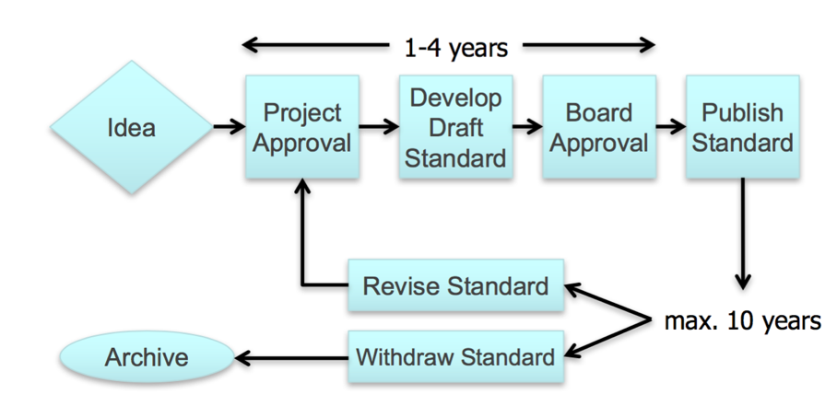

To expand my scope of the standard, I also browsed the great ISO standard development process.

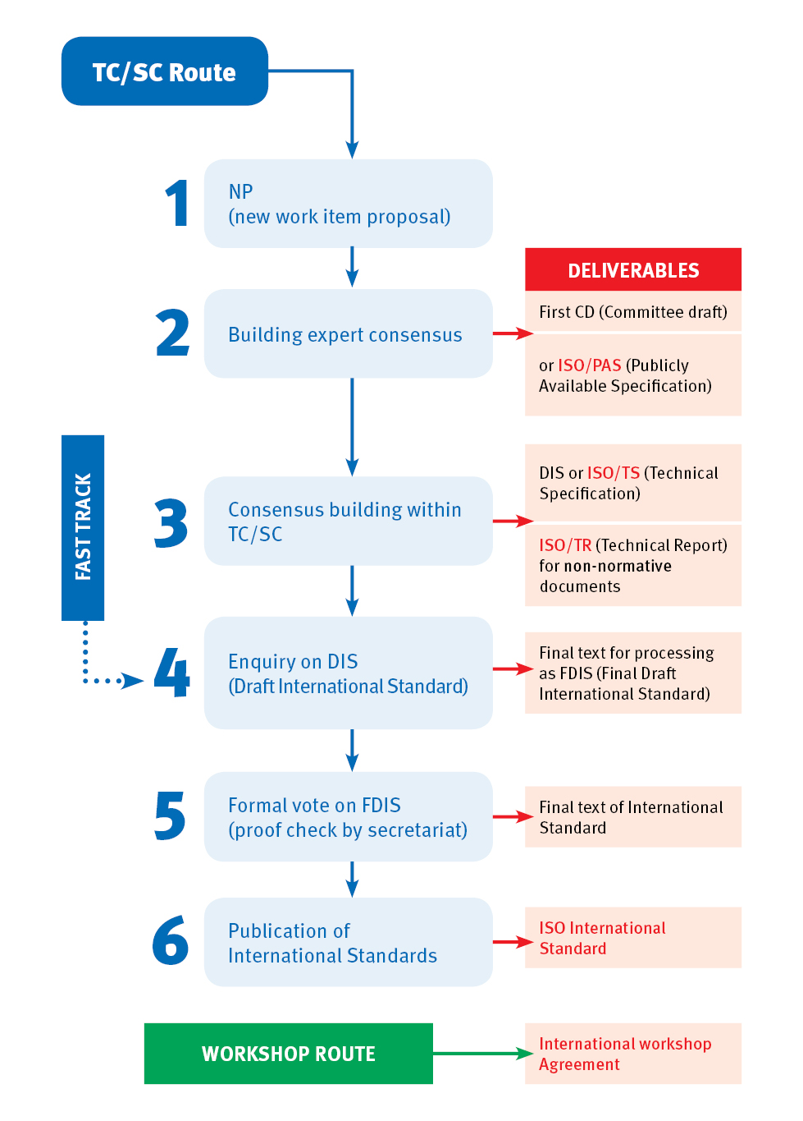

Shown as the flow chart above is the detailed process of development. The ISO illustrated an interesting example. It compared the technical experts to the orchestra and compared the ISO to the conductor. Everyone in different aspects composed the ‘standard’ symphony together. In the first stage, specialists in the technical committee begin to constitute a draft which fulfils the market demand and process a further discussion. Then a vote is held for the ISO members to reach a consensus, which determines whether the draft is approved to become a new ISO standard or not. This entire process always takes about three years.

In the tutorial, the facilitators described some distinct circumstances under the standards or not. Then reasons for establishing and developing standards are covered. Meanwhile, for reinforcing these concepts, they provided some activities to us. What impressed me a lot is the new design of a course (International relationship). This topic attracted our group, and I could not help talking with Chin and Liming. We decided the detailed assessment, which is three assignments in 20% for each with a take-home exam worth 40%. Besides, the working time for each week is also determined. One colleague reminded us that as a construction of a course, this is not sufficient. Thus, we proceeded our second discussion and facilitators invited Chin to demonstrate on the white board in detail. These contributions adequately strengthen my understanding on the Industry Standard.

To some extents, standard plays a significant role in the development of SE and the history of human development. However, things are not always smooth. Next week’s topic is the human error, which will introduce some negative aspects caused by people.

Week 8

In this week’s lecture, Dr. Robyn Clay-Williams delivered the topic of Human Error to us. She emphatically demonstrated the impact of human error and the reason why we researched on human error. Sometimes people may hold wrong ideas that his/her personal mistake is too tiny to result in a fateful accident or failure. However, a series of individual errors are possibly able to accumulate to a terrible consequence. For instance, in the video she displayed to us, a serious medical accident that the patient was injected a kind of incorrect anticancer medicine due to the complexly interpersonal communication between doctors in different departments, inadequate preparation and unreasonable arrangement in physicians and nurses.

What impressed me is that her response to the interesting question why not delete humans from the systems since human errors are everywhere and ineluctable. She answered that although people can purely play the role of a supervisor in the system and the development of automatization is mature, humans are impossible to escape from the system. Apparently, the setting and initialization of the system are determined by human beings, and any human interference in the system is unavoidable. Nonetheless, a derived question was come out of my mind– why not remove the human intervention?

In my opinion, the human intervention is accidental which is hard to inevitable. Imaging people are figuring out large amounts of incidents and processes in a complicated system, do you think they do have much time on considering and predicting the accidents? The case of the Smiler Roller-coaster Incident in the tutorial facilitation confirmed my point of view. The terrible accident was caused by the collision between the train with 16 riders and the speed of approximately 32 km/h and an empty train. According to the report, a safety mechanism was for preventing two trains on one track, and it had detected the previous empty train was stopped. Then the engineers allowed a ride operator to dispatch the empty train which led to the crash manually. If the engineers got notified and paid attention to the warning from the ride control system, then directed the ride operator not to move the empty train, the accident would be avoided. However, how to ensure the engineers is not with complacency and full of awareness at all times? Thus, the emphasis of learning this lecture is to minimise the impact of human errors and summarise the experience from the previous accidents and operations instead of removing human or human interferences from the system.

In retrospect, I also have made some human errors. For example, due to my bad memory, I always forget to click the ‘save’ button after I finished the work on the laptop. The Microsoft Word has the tip to remind you to save the word, while the rPeANUt, a compiler designed by Eric and taught in the course COMP2300, does not have the function. I remembered once I finished the pix drawing picture and also got an excellent test result, then I closed the window and planned to upload the code and submitted it. However, as I did not save the code, the code file is empty. So I had to type the code again. My old smartphone was Android system, and I always downloaded some Ads and malware which result in the crash of the phone system. Now I use iPhone and often backup for the system for the emergency when the phone crashes and is never powered on.

Humans established several standards to manage the industry but cannot avoid the human errors due to the interaction impact and relationship between people and system. Sometimes system is significant to optimise the efficiency and profit, while sometimes people have to break the constraint and regulation of the system to ensure the safety and optimal function of it. Now, Artificial Intelligence is not able to reach the technical degree. Therefore, at this stage, human errors are also a precious wealth for people to promote the technology and the awareness.

Week 9

This week’s lecture, from Dr. Matt Wilcox, was on the topic of cyber security, which is a closely relevant aspect of our daily life. He firstly came up with a puzzling question: what is the difference between cyber security and IT security. These two concepts confused the present students, and one guy sat on my left said cyber security and IT security are so closely connected, even they are always regarded as synonyms. I was wondering as well until I searched on the Google and got the answer. In my opinion, IT security pays more attention to the information, while cyber security concentrates on protecting data which is in the electronic form. There are some overlaps between the two concepts. For instance, they all recognize the value of the data and have an important security component – access. People always use locks to prevent anyone with criminal minds from rummaging the confidential paper documents. Similarly, for cyber security, people set the access control, which is like a virtual padlock on the servers/computers, for defending the behavior of obtaining access from unauthorized users.

After I figured out the distinctions, he then described the factors which result in the increase of the cybercrimes and appropriate tools and classifications of it. This is the something I am interested in. As a potential victim and a future engineer/defender, understanding the criminal process and accumulating experiences are the best weapons. Spear phishing, spam sites, malware and botnets are common performances by their tools (bugs, exploits and implants). However, besides avoiding mandatory installation of software, users should also take some actions. Last year when I learned the network in COMP2410, it mentioned the concept of PKI (public key infrastructure), which reinforce the security level in communications and information exchange. The digital certificate authentication of it plays a significant role in message encryption. First, a verifier sends Challenge Message to a supplicant, which claims to be a true party. Then the supplicant encrypts the Message with its own private key and replies a Response Message. Next, Certificate Authority offers a digital certificate of the true party and public key of true party to the verifier. Finally, verifier decrypts Response Message with the public key of the true party instead of the supplicant’s public key. It is no doubt that this operation, which adds the cryptography to the communication, strengthen the information and transmission security.

During the facilitation tutorial, James and his team illustrated a simple case – password. Password is the fundamental safeguard for everyone. Financial criminal groups may notice your bank account and spies hack your social media account and network to steal state secrets and harm the security if your password is weak or easy to crack although people always set simple passwords to memorise for convenience. Meanwhile, the team also indicated the timely repair of exploits and to use ‘fixes that fail’ system to design a more efficient and safe solution when the company and employees encounter some issues.

Cyber security is a related topic in the society but always be ignored. People often consider hackers will not notice their accounts in the crowd. Small and medium businesses may decrease the IT budget to save money and create more profits. I strongly suggest people and managers in small enterprises are able to have a chance to understand the importance of the cyber security then increase the awareness and alerts to be eligible defenders.

Week 10

This week’s lecture was on the contextual and commercial aspects of Engineering, which was given by the Geoff Patch and Merv Davis from CEA Technology. The lecture was divided into two parts. First, Geoff introduced the concept of engineering context by displaying his proud Radar Defence System that is designed by his team, which focuses on the existing development and requisites of the engineering issues and solutions which development produces. Moreover, he also illustrated that you possess high-level skills and ethics live around is not sufficient to be a successful engineer. As far as I am concerned, a great engineer requires not only the features above but also the capability of organisation and management in spite of his/her engineering context, and an actual engineering solution is impossible to isolate in only technical and ethical environment. In addition, communication skills are also an assessment for success in an engineering team. The success is from team members interact, inspire and communicate with each other rather than the team pay more attention to the engineering context. I ever did the group work in COMP3120 and COMP2410. In my impression, the group always had a leader to manage and distribute the tasks, and other team members are responsible for their missions. Although all colleagues studied the course from the same stage and were not familiar with the work, the process became easier after applying the efficient method.

After a short break, Merv began to demonstrate the commercial aspect of engineering. Apart from the design, the context and test aspects of software and engineering, the root aim of the software and engineering is application and sale. There is no absolutely free software in the world, and most of the allegedly free software is with the advertisement. Thus, in my opinion, focusing on the commercial part is necessary. Mr. Davis primarily discussed on the sales during the tender period. The success of the sale of software is to distinguish your products from other competitors’, apparently, including some detailed requirements, such as how to sell a product to a customer without any specific wish list and how to make a distinction between your products and others’ completely. With the question, I listened to Mr. Davis indicated the important concept – optimisation. As Geoff introduced before, all the engineering solutions are in the complex context and system. When a company tries to win the tender, it always encounters that the clients do not actually ensure what they require. The salesmen may introduce more related products, like the Radar Defence System case, they can sell more anti-missile system products. However, when clients know they realised the threat target is from the battleplane, the company will lose the opportunity of the tender. Thus, I think the optimisation is that when selling a defence system, the company should investigate and analyse sufficient samples of potential requirements and do not leave any inflexible information. Salespeople are able to introduce any threat targets they could locate to the clients until they obtain a particular one or direction. Then after signing the contract, increase the defence level on the direction of the specific target.

To sum up, engineering influence on our daily lives and society, while it also has an adverse effect on the development of weapons. Thus, the social influence of an engineer is huge. As an engineer, he should be not only responsible for dealing with problems and building the system but also ensure the solutions will not create terrible impacts on others. For the commercial part, if the company could minimise the requirement of clients and introduce your features as much as you have to them, the sales will be on track. This optimisation can be considered as a strategy for a company.